B.K. Jewellers

**Function Requirement Specification (FRS)**

**Document for**

**“Stock management” department.**

Document NO: 001

Date: 13-02-2020

Prepared by:

Group 2

* **Revision History**

|  |  |  |  |
| --- | --- | --- | --- |
| **Revision Number** | **Revision Date** | **Summary of changes** | **Author** |
| **1** | 13/02/2020 | Document made. | Rudra soni |
| **2** | 18/04/2020 | * **Table of content:** Page numbers added. * (**2.1 IMAGE**)**:** Indicators added. * **(2.1):** Button state (active) added. | Rudra soni |
| **3** |  |  |  |
|  |  |  |  |

* **Table of Contents** -

|  |  |  |
| --- | --- | --- |
| Sr.  No. | Content | Page  No. |
| 1. | Introduction |  |
|  | * 1. Objective | 4 |
|  | 1.2 Scope | 4 |
|  |  |  |
| 2. | Functional Description |  |
|  | 2.1 Accountant | 4 |
|  |  |  |
| 3. | System hardware | 9 |
|  |  |  |
| 4. | Security | 9 |
|  |  |  |
| 5. | Regulatory requirement |  |
|  | 5.1 Accurate record generation | 9 |
|  | 5.2 Timeouts | 10 |
|  | 5.3 Operational system checks | 10 |
|  | 5.4 Electronic signature manifestation | 10 |
|  | 5.5 User password controls | 10 |
|  | 5.5.1 Password expiration | 10 |
|  | 5.6 Additional system controls | 10 |
|  | 5.6.1 Event logging | 10 |
|  | 5.6.2 System access | 10 |
|  | 5.6.3 Input checks | 11 |

1. **Introduction**
   1. Objective:

This is the functional requirement specification (FRS now onwards) for “stock management” functionalities used by stock management department of **B.K. Jewellers.**

The FRS is details the capabilities and functions that the software must be capable of and reliably perform functionalities.

* 1. Scope:

This document applies to the “Stock management department” of software. The document will address the functions of “Stock management department” must be able to successfully perform primary business requirements. The focus is on what the “Stock management department” must do.

1. **Function description**
   1. Stock manager

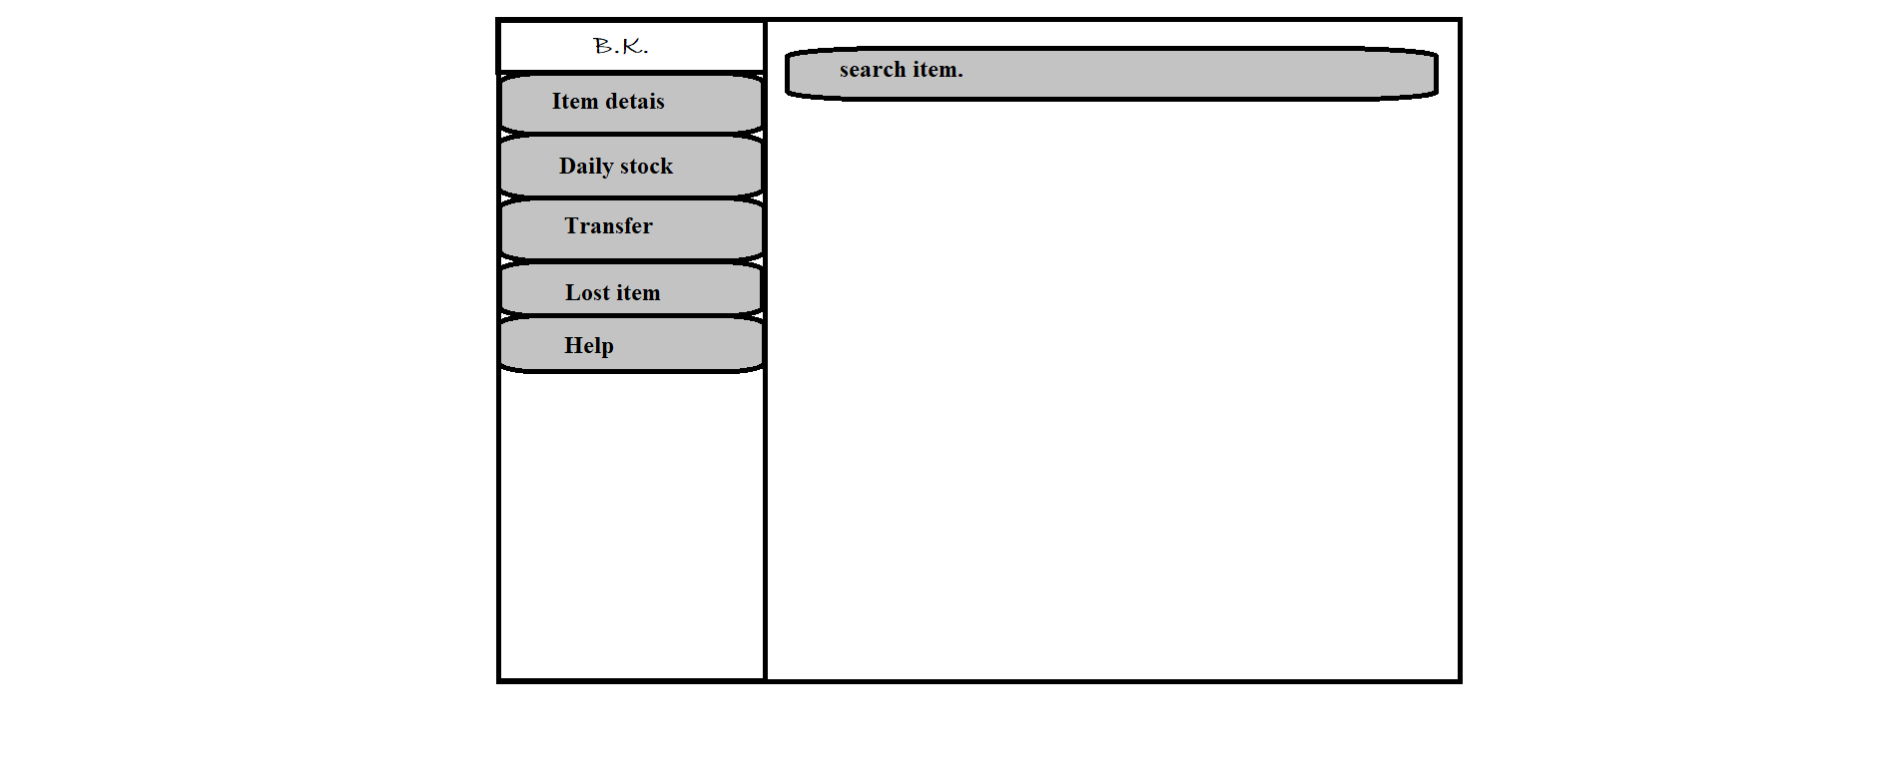

G

F

E

D

C

B

A

1. Logo

* Type: image
* Use: only for design
* Events: none
* Source: BKlogo.png

1. Item detail

* Type: button
* Text on button: Item detail
* Background colour(Active): gray
* Use: to view full details of an item.
* Events:

click:- user will have to enter item code and pres submit button and then full details will be displayed.

Hover:- display information (text) “item detail.” below mouse arrow.

* Functions:
* A text field will be shown in which user will have to enter item code.
* When submit button placed at bottom-right corner is clicked, information will be shown in form same as at the time of adding new item to the stock will be displayed.
* After clicking print button placed on below right corner, form has been sent to get printed via connected printers.

1. Daily stock

* Type: button
* Text on button: Daily stock
* Background colour(Active): gray
* Use: used for daily scanning of stock.
* Events:

click:- navigate user to a new window which contains two columns, one is full of available stock list and other is empty which is used for counting.

Hover:- display information (text) “daily stock scanning.” below mouse arrow.

* Functions:
* When clicked user will navigate to a new window which contains two columns side by side, one is full of available stock list and other is empty which is used for counting.
* When a barcode of an item is scanned, it will match the data and transfer that item from right column to right column.
* If any barcode is scanned twice, scanning process will be stopped at that point.
* After completion of scanning user will click submit button placed on bottom right corner.
* When submit button is clicked all data will be stored into database with date and completion time.

1. Transfer

* Type: button
* Text on button: Transfer
* Background colour(Active): gray
* Use: to change location of item.
* Events:

click:- navigate user to preformatted location transfer voucher (source: loctransfer.xlsx) into editing mode.

Hover:- display information (text) “location transfer.” below mouse arrow.

* Functions:
* Automatic new voucher number will be generated.
* When button is clicked user will navigate to preformatted location transfer voucher (source: loctransfer.xlsx) into editing mode.
* User will have to add items by scanning barcodes only.
* When a barcode of any item is scanned, the item is shown on right column with its full details submitted on adding to the stock.
* When submit button is clicked a preview of voucher will appear and all scanned items will added to stock of destination location and removed from current location.

1. Lost item report

* Type: button
* Text on button: Lost item
* Background colour(Active): gray
* Use: to generate a report of missing item from the stock.
* Events:

click:- user will be navigate to new window which contains preformatted report (source: lostreport.xlsx) in edit mode.

Hover:- display information (text) “missing item report.” below mouse arrow.

* Functions:
* When button is clicked, user will be be navigate to new window which contains preformatted report (source: lostreport.xlsx) in edit mode.
* After entering item code, all details of an particular item will be displayed in respective fields.
* When submit button placed at bottom-right corner of window is clicked, the report will be sent to get printed via connected printers automatically.

1. Help

* Type: button
* Text on button: Help
* Background colour(Active): gray
* Use: to acknowledge the user.
* Events:

click:- a help page (source: help.docx)will appear which contains all information of every single step.

Hover:- display information (text) “help.” below mouse arrow.

* Functions:
* When button is clicked help.docx page will appear in full window.

1. Search

* Type: Search bar
* Placeholder:
* Use: search any invoices and items.
* Events:

click:- activate keyboard for input.

* Functions:
* When user click on search bar keyboard will be activated for input.
* When “Enter” button is clicked after any invoice number or item code is entered software will search matching data from database and show all details and last operation done on item in new window.

1. **System hardware**

The software can run on the minimum standard PC workstation or laptop configuration by **B.K. Jewellers.** This part can be accessible by all PC present in workgroup of organization for “Stock management”.

This part of the software does not affect the organization LAN.

1. **Security description**

The sales part is only accessible through the software provided by “BlackSky Systems.” This software or any part of the software does not open from outside the configured environment of **B.K. Jewellers.**

1. **Regulatory requirements**
   1. Accurate record generation:

It has ability to generate accurate and complete record in both human readable and electronic form suitable for inspection & review by regulatory agencies.

The functionality meets the following requirements:

* The ability to generate accurate and complete copies of record in both human readable and electronic form suitable for inspection & review by the agency.
* Users are able to select search queries.
* Users are not able to customise criteria used to view data from search.
* Users are able to export data through MS Excel
  1. Timeouts:

The software for “Stock management department” will not automatically time-out, it is supposed to run after login till the user won’t logout from the system.

* 1. Operational system checks:

The “Stock management department” software uses operational system checks for permitted sequencing of steps and events.

* 1. Electronic signature manifestation:

The software has secure data in system through electronic signatures. Data secured with an electronic signature cannot be edited or deleted unless the signature is removed.

* 1. User password controls:

This software does not allow user to change their passwords. Only the administration has this authority.

5.5.1 Password expiration:

Once the password is created it never expires unless user requested to change it.

* 1. Additional system controls:

5.6.1 Event logging:

It includes system login and logout, as well as attempts failures.

5.6.2 System access:

Access to software must be controlled by user access to the LAN controlled by system identification and password.

5.6.3 Input checks:

When appropriate entries may programmatically checked before being accepted by software.(for example, No negative values accepted for item price.)